AXI Stream Tutorial

HLS IP Design
- Extract the provided zip file and take the example.cpp file as the source file for the HLS deisgn
- Open Vitis HLS, import example.cpp, set top function, run synthesis and finally package the IP like we did in the previous adder tutorial
- Understand what the function does

Vivado System Design
- Open Vivado and create a project.
- Then In Vivado, you need to run a tcl script to generate the base block design. Within the Vivado Integrated Design Environment (IDE) you can source a Tcl script from Tools > Run Tcl Script.
The tcl file is in the zip file. The base design is shown below.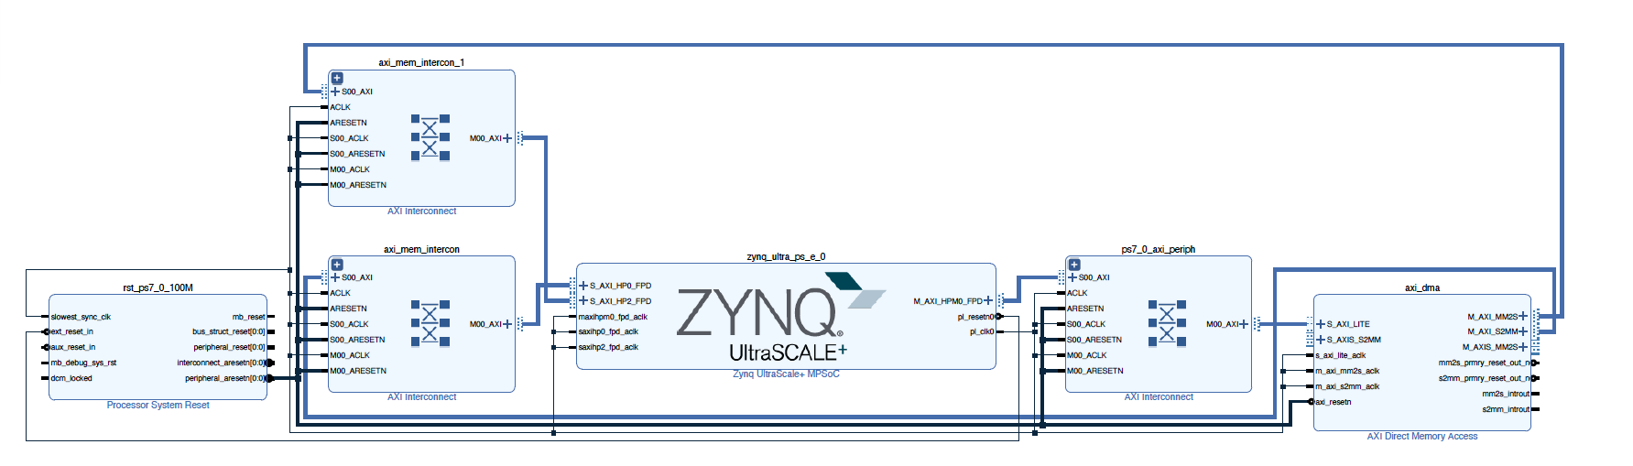
- Import your packaged IP
- Add the IP into the generated base block design
- Run block automation to automatically connect (select those in the automation window) the HLS IP’s AXI control interface (s_axi_control), the clock (ap_clk) and the reset (ap_rst_n)
You can then connect the AXI stream interfaces of the HLS IP to the DMA
M_AXIS_MM2S → A
B → S_AXIS_S2MM
The block design will be like the following.
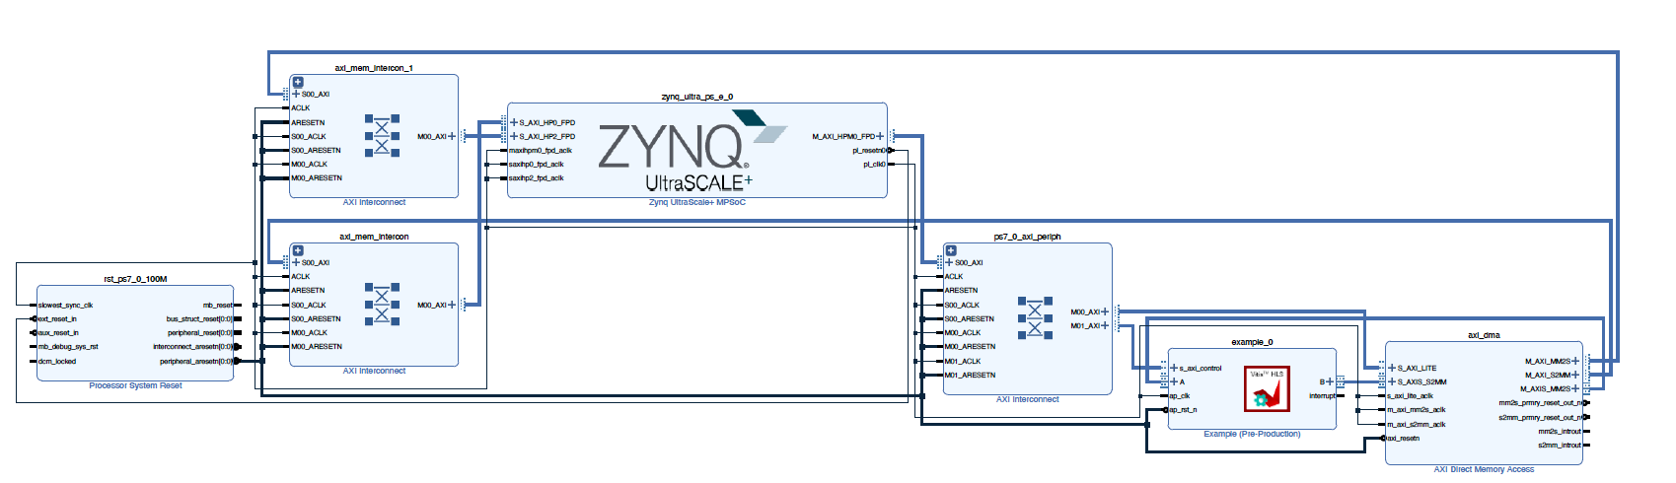

- Generate the HDL wrapper and build the bitstream. This might take a while.
- Once the bitstream is complete, you can find the HWH and the BIT file and and copy them to your board running Jupyter Notebook

DMA background
The DMA allows you to stream data from memory, PS DRAM in this case, to an AXI stream interface. This is called the READ channel of the DMA. The DMA can also receive data from an AXI stream and write it back to PS DRAM. This is the WRITE channel.
The DMA has AXI Master ports for the read channel, and another for the write channel, and are also referred to as memory-mapped ports - they can access the PS memory. The ports are labelled MM2S (Memory-Mapped to Stream) and S2MM (Stream to Memory-Mapped). You can consider these as the read or write ports to the DRAM for now.

Control port
The DMA has an AXI lite control port. This is used to write instructions to configure, start and stop the DMA, and readback status.

AXI Masters
There are two AXI Master ports that will be connected to the DRAM. M_AXI_MM2S (READ channel) and M_AXI_S2MM (WRITE channel). AXI masters can read and write the memory. In this design they will be connected to the Zynq HP (High Performance) AXI Slave ports. The width of the HP ports can be changed in the Vivado design, however these ports are configured when PYNQ boots the board. You need to make sure the width of the ports in your Vivado design matches the PYNQ boot settings. In all official PYNQ images, the width of the HP ports is 64-bit.
If you set the HP ports to 32-bit if your design by mistake, you will likely see only 32-bits out of every 64-bits are transferred correctly.

AXI Streams
There are two AXI stream ports from the DMA. One is an AXI master Stream (M_AXIS_MM2S) and corresponds to the READ channel. Data will be read from memory through the M_AXI_MM2S port and sent to the M_AXIS_MM2S port (and on to the IP connected to this port).
The other AXI stream port is an AXI Slave (S_AXIS_S2MM). This is connected to your IP. The DMA receives AXI stream data from the IP, and writes it back to memory through the M_AXI_S2MM port.
If the IP is not ready to receive data from the M_AXIS port, then this port will stall. You can also use AXI Stream FIFOs. If the IP tries to write back data but a DMA write has not started, the S_AXIS channel will stall the IP. Again, FIFOs can be used if required. The DMA has some built in buffering so if you are trying to debug your design you may see some (or all) data is read from memory, but it may not necessarily have been sent to your IP and may be queued interally or in the HP port FIFOs.

Testing on Your PS
- Copy your design files to the board (.bit and .hwh)
- Instantiate and Download the overlay
from pynq import Overlay

ol = Overlay("<your path>")
- We can check the IPs in this overlay using the IP dictionary (ip_dict).
ol.ip_dict

- The HLS has the default name from the Vivado project of example_0.
Check help for the HLS IP:
ol.example_0?

- Using the labels for the HLS IP and DMA listed above, we can create aliases which will make it easier to write and read the rest of the code in this example.
dma = ol.axi_dma
dma_send = ol.axi_dma.sendchannel
dma_recv = ol.axi_dma.recvchannel

hls_ip = ol.example_0

- Check the status of the HLS IP
hls_ip.register_map

Note that the HLS IP is not started yet (AP_START=0). You can also see the IP is idle (AP_IDLE=1).
We will start the HLS IP and then start some transfers from the DMA.
We could initiate the DMA transfers first if we preferred. The DMA transfers would stall until the IP is started.

- We can start the HLS IP by writing 0x81 to the control register. This will set bit 0 (AP_START) to "1" and bit 7 (AUTO_RESTART) to "1". AUTO_RESTART means the IP will run continuously. If we don't set this then after the IP completes one full operation or iteration, it will stop and wait until AP_START is set again. We would have to set this every time we want the IP to process some data.
CONTROL_REGISTER = 0x0
hls_ip.write(CONTROL_REGISTER, 0x81) # 0x81 will set bit 0

Check the correct bits have been set.
hls_ip.register_map

- Now we will send some data from DRAM to the HLS IP.
Note the array used below is uint32. This was selected to match the type of data width of the HLS IP and the widths used for the DMA. The DMA will transfer blocks of data and may "reformat" it based on the internal data widths in the hardware. The array we create in the notebook effects how the data is formatted in Python. This is an area that can cause problems so it is worthwhile checking you understand your data formats and data movement in your hardware.

from pynq import allocate
import numpy as np

data_size = 100
input_buffer = allocate(shape=(data_size,), dtype=np.uint32)

Initialize the array.

for i in range(data_size):
input_buffer[i] = i

Start the DMA transfer.
dma_send.transfer(input_buffer)

Readback data from the HLS IP and store in DRAM. Start by creating the output buffer

output_buffer = allocate(shape=(data_size,), dtype=np.uint32)

dma_recv.transfer(output_buffer)

- Print first few values of buffer
The result from the HLS IP should be "i"+5

for i in range(10):
print('0x' + format(output_buffer[i], '02x'))

verify that the arrays are equal

print("Arrays are equal: {}".format(np.array_equal(input_buffer, output_buffer-5)))

- Free all memory buffers
del input_buffer, output_buffer

